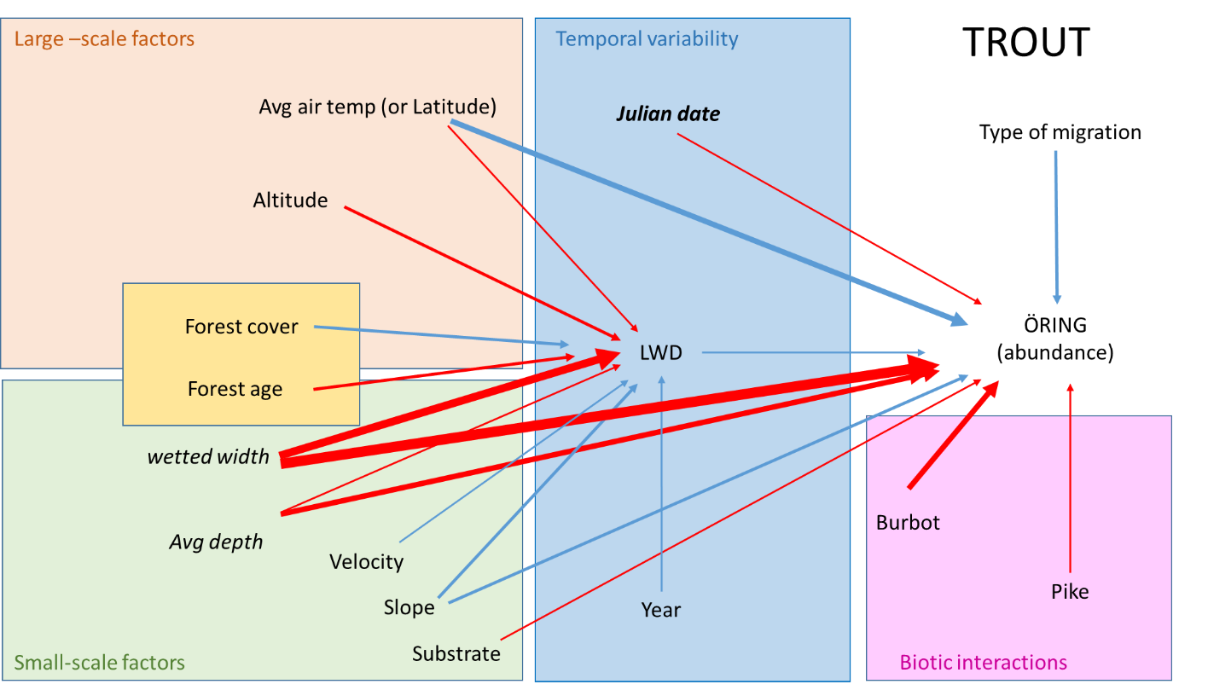

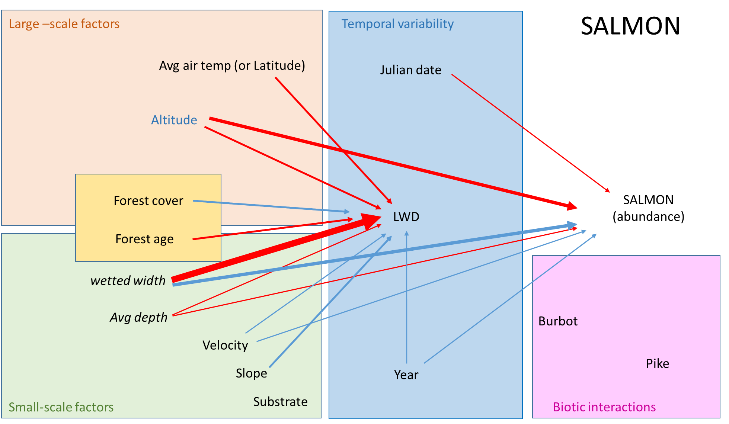

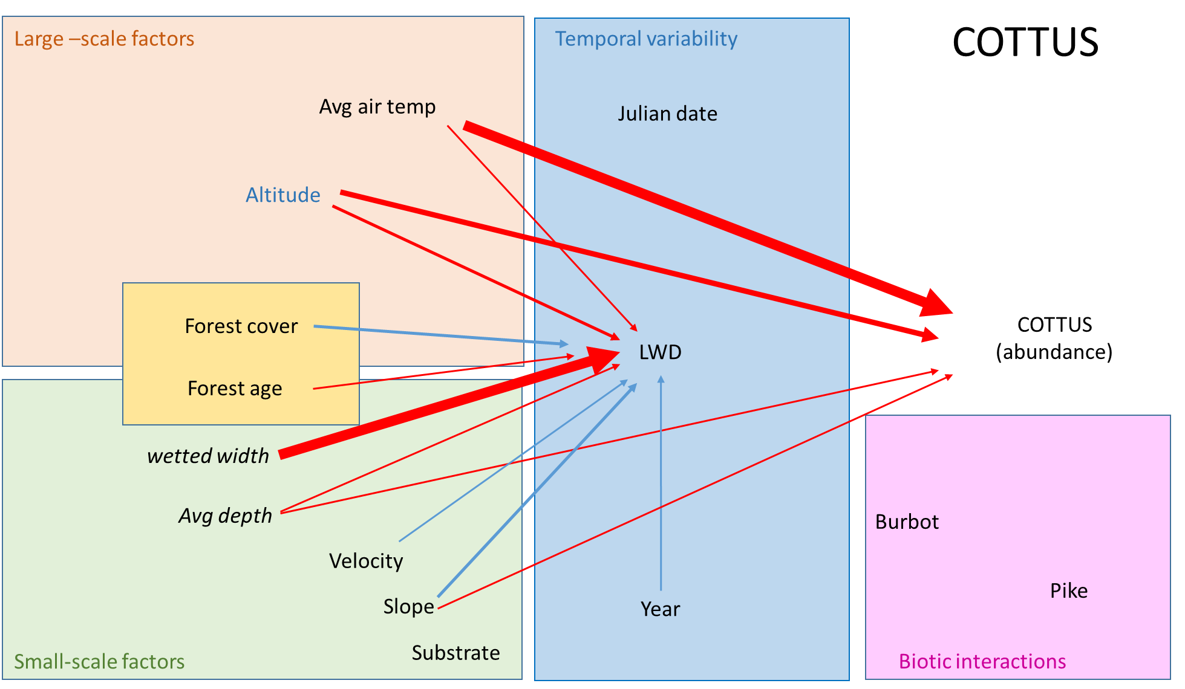

­Running head:

TITLE

The relative importance of direct and indirect effects of large scale and local factors for stream fish population

Direct and indirect effects of large and small-scale drivers of fish abundance in streams

Dead wood mediates effects of large and small-scale factors on fish abundances in stream ecosystems

Manuscript type: Article

**ABSTRACT**

Identifying drivers of fish abundance in running waters is challenged by high variation in physical conditions at both large and local spatial scales. Several fish species perform migrations upstream and downstream, covering longitudinal gradients in climatic and geographic factors. Moreover, streams typically encompass highly diverse adjacent habitats, where environmental conditions, such as water velocity, depth, and substrate, vary within short spatial ranges. Among the local-scale factors affecting fish abundance, the occurrence of woody debris has been reported to boost salmonid fish population growth. However, what species benefit from woody debris, to what extent relative to other biotic and abiotic drivers, and what factors influence woody debris local quantity is not clear yet, which limits our ability to use woody debris as an effective restoration measure.

We analyzed time series data collected between 1993 and 2016 from 3653 rivers (total of ca 7000 sampling sites) all over Sweden to investigate 1) the relative importance of large-scale and local factors for the abundance of three key freshwater fish species: salmon (*Salmon salar*), brown trout (*S. trutta*), and sculpin fish (*Cottus* spp.), 2) whether local abundance of woody debris has beneficial effects on these three species, and 3) the drivers of woody debris persistence.

We found that large-scale factors such as annual mean air temperature and altitude mainly explained *Cottus* abundance (negative effects), while local stream width was the strongest predictor of trout and salmon abundance, with negative and positive effects, respectively. Trout abundance also decreased with local stream depth and abundance of burbot, a predatory species, while it increased with mean air temperature. Woody debris appeared to benefit trout, but not salmon or *Cottus* spp. abundance. The quantity of woody debris strongly decreased with stream width, but also depended, albeit to a lesser extent, on stream bed slope, forest age and cover, altitude, and mean air temperature. Our study suggests that the weight of large- and local-scale factors on fish abundances in streams varies strongly with species, and that effectiveness of woody debris as a restoration measure depends on both the targeted species and local environmental conditions.

**Keywords**:

**INTRODUCTION**

Both economically and non-economically valuable fish population provides a range of ecosystem services for human societies (Holmlund and Hammer 1999). Fish populations are however undergoing increasing pressures (e.g. overfishing, habitat loss, climate change REF) in both marine and freshwater ecosystems, and is therefore crucial to understand drivers of abundance and distribution to aid management and conservation.

~~Theory and empirical studies show that distributions of fish among other species are generally determined by abiotic factors at regional scales (check Jenkins and Ricklefs 2011).~~

It is commonly accepted that large-scale processes/ processes and factors acting on larger spatial and temporal scales structure species assemblages/determine the coarse distribution of species by selecting/filtering the pool of potential available species/by determining the potential range that any given species can occupy (Tonn et al. 1990, Ricklefs 1987, Moran-Lopez 2012). On the other hand, behavioral, morphological, and physiological adaptations to local conditions, as well as biotic interactions (competition and predation), have a strong influence on where and when a species will be found (Grossman et al. 1998 in Jackson et al 2001, Jackson et al 2001, Tonn 1990). A number of studies has addressed fine-scale habitat use of fish in freshwater systems, often in relation to competition and predation (e.g. check Gorman & Karr, 1978; Schlosser 1982 in Moran-Lopez and find recent), while others have focused on large-scale drivers of distribution across systems./major abiotic constraints at large-scales (e.g. Magalhaes et al., 2002).So far, however a unified approach for understanding the relative importance of large- and small-scale drivers has rarely been implemented due to/ been prevented by the availability of resources to data collection, as well as the questions considered (Jackson et al. 2001). An integrated framework would be especially helpful for management purposes, as habitat restoration measures typically focus on the modification of local conditions (e.g other + removal of predators or competitors ….) to the benefit of the targeted species but have no power on large-scale drivers. Moreover, the effectiveness of such restoration measures may be conditional on the specific abiotic and biotic context considered. / (Given that) habitat restoration measures typically focus on the modification of local conditions (e.g other + removal of predators or competitors ….) and that their effectiveness is often/may be conditional on the specific abiotic and biotic context (ref),

It is therefore important, for both our ecological understanding and management purposes, to evaluate together the relative weight of large-scale, small-scale and biotic factors in driving species distribution, and to assess potential context-dependent (interactive) effects. /An integrated framework is therefore needed where large-scale, small-scale and biotic factors are weighted against each other and context-dependent (interactive) effects are evaluated.

The assessment of drivers of fish abundance in running waters is further challenged by broad variation in environmental conditions at multiple spatial and temporal scales /at both large and local spatial scales (Jackson et al. 2001, Cooper et al. 1998 find more recent). Rivers typically form vast interconnected networks that include strong longitudinal gradients of climatic and geographic factors. Maybe example of how large scale factors influence one rather than another spp, or: while the occurrence of some species is restricted to.., other fish spp migrate long distance upstream and downstream. On the other hand, streams offer a multitude of different habitats, where local conditions such as depth, water velocity, and substrate composition can vary widely within short spatial ranges (within few meters), and over time, due to fluctuations in stream flow (Cooper et al. 1998, Grossman and Freeman 1987 find more recent). It is well known that many species have specific preferences for..(look at grossman and freedman and Degerman et al. 2000)Such habitat partitioning is the result of / Also, predation and to a less extent competition, further costrain/structure fish assemblages (look at Jackson).

Among the local-scale factors affecting fish abundance, the occurrence of woody debris is suggested to benefit fish population growth by providing refugia from predators and elevated flow, and substrate for spawning and feeding (Degerman et al. 2004, Dollof and Warren 2003, Crook and Robertson 1999, Sievers et al. 2017). However, beneficial effects of woody debris are mostly reported for juvenile and adult salmonids, while evidence for non-salmonid fish is equivocal (Roni et al. 2014, Langford et al. 2012). Furthermore, Therefore, what species benefit from woody debris and to what extent relative to other biotic and abiotic drivers is not clear yet. Furthermore, several knowledge gaps remains on the factors affecting woody debris abundances and persistence (Seo et al. 2010), which limits our ability to use woody debris as an effective restoration measure.

In the current study we analyzed time series data from 3653 rivers (total of ca 7000 sampling sites) across Sweden to investigate 1) the relative importance of large-scale and local factors for the abundance of three key freshwater fish species: salmon (*Salmon salar*), brown trout (*S. trutta*), and sculpin fish (*Cottus* spp.). Specifically, we asked 2) whether local abundance of woody debris had beneficial effects on these three species, and 3) what drivers determined woody debris persistence. We used path analyses (Grace 2006), a statistical technique that allows not only to evaluate simultaneously the relative strength of multiple causal links, but also to assess indirect effects, hence the significance of woody debris as mediator factor for fish abundances.

Sentences

Understanding drivers of fish abundance in running water is pivotal/essential for conservation and effective restoration.

Understanding drivers of fish abundance in running water is challenged by high spatial and temporal variation in physical conditions at both large and local scales.

However Moreover, streams also/typically encompass high spatial and temporal variation in local conditions, such as water speed, depth, slope, substrate type./Furthermore, physical conditions in streams can vary strongly on short spatial and temporal ranges, thus offering a variety of habitats/resulting in highly diversified habitats on short ranges.

Third/finally, biotic pressures such as competition and predation may further constrain the occurrence

Such high large and small scale spatial variability together with seasonal variations, long term dynamics and the effects of predators and competitors /High large and small scale variation in physical conditions, together with biotic drivers of fish distribution such as competition and predation, challenge our understanding of the relative importance of large- vs local-scale drivers of fish abundance in streams

**METHODS**

*Data*

The dataset was extracted from the Swedish Electrofishing Register (SERS) and consisted of 33278 records from 9096 sites spread in 3641 rivers across Sweden. Each site was sampled up to twenty times but at least once between 1993 and 2016. Electrofishing was performed when? along sections on average 45 ± 23m (SD) long and spanning the whole width of the river, by using DC-equipment from LUGAB or BIOWAVE (Sweden). The abundance of each fish species was estimated through successive removals according to Bohlin (1984), and expressed as number per 100m2. For the current study we used abundances of three key species: salmon (*Salmon salar*), brown trout (*S. trutta*), and sculpin fish (*Cottus* spp.). Type of migration Salmon and brown trout we re classified either as migrating or resident based on..

In each sampling occasion, stream width (5 ± 4m, mean ± SD), average depth (0.23 ± 0.11m, mean ± SD), maximum depth (0.55 ± 0.22m, mean ± SD), water and air temperature () were measured. The date of fishing was expressed as Julian date (ranging from 1 to 366). The bottom substratum was classified into 5 categories, from 1 to 5, according to increasing particle size (fine: <0.2mm, sand: 0.2–2mm, gravel: 2–20mm, stones: 20–200mm, boulders: >200mm). Water velocity was scored from 0 to 3 with 1 being slow flow and 3 being rapids. Woody debris with diameter ≥ 10 cm and length ≥ 50 cm were counted and given as number per 100 m2.

For each site, stream slope (%), altitude (m a.s.l.), latitude, distance to the sea (m) and forest data were estimated in a GIS environment using ArcMap 10.2. Forest data were collected in 2000, 2005 and 2010, and were matched respectively with electrofishing data collected before and during 2000, between 2001 and 2005, and from 2006 onwards. Coverage (ha), mean forest age (years), and total forest volume (m3) from 25mx25m pixels were averaged from an area of 700m diameter and 150 hectares surface around each sampling site. Average air temperatures between 1960 and 1990 were provided by the Swedish Meteorological and Hydrological Institute (www.smhi.se).

STAT

Relationships between response variables and total water volume sampled (calculated as width*length*average depth of the sampled section of each site) did not show issues related to the size of the sampled area. We consider rivers rather than sites as replicates to simplify the hierarchical structure of the data and overcome mislabeling of site names. However, we wanted to keep the year-to-year/temporal variation to investigate changes over time. Hence, averages by rivers and year for all predictors and response variable were calculated. Collinearity among explanatory variables as well as their contribution to environmental variation between rivers was explored by means of principal component analyses (PCA) after gradient lengths were found < 2 in a detrended correspondence analysis (DCA) (ter Braak and Smilauer 2002). Abundances of each fish species and woody debris were log-transformed to attain normal error distribution.

*Path analysis*

We used path analyses to evaluate 1) the contribution of large and local-scale factors in explaining the abundance of salmon, brown trout and sculpin, 2) potential beneficial effects of woody debris on the abundance of these three species after accounting for the effects of other explanatory variables, and 3) drivers of woody debris abundance, which could indirectly affect fish abundance. We first formulated hypotheses based on current empirical and theoretical knowledge of drivers of fish abundance and wood debris in running waters. We hypothesized that large-scale factors such as climatic and geographic factors (i.e. latitude, altitude, average air temperature, and distance to the sea)

Alternatives: 1) hypotheses on that large scale have stronger effects than the others. Is this supported by literature?

2) hypotheses on specific effects of each factor.

3) just report causal links considered without explicitly calling them hypothesis.

Where to list the grouping of my variables? i.e. large scale, local scale, biotic, temporal . Is it necessary?

After formulating the conceptual model, we used path analysis to test the significance of causal links (paths) corresponding to each hypothesis. Models included n exogenous variables: i)……. Endogenous variables included biomass of i) piscivorous fish (perch and pike pooled), ii) three-spined stickleback (the dominant mesopredator), iii) grazers and iv) epiphytic algae (percentage of total above-ground vegetation biomass), and v) percent cover of total vegetation (excluding epiphytic algae). As preliminary analyses did not show any significant relationships between roach and grazer biomass, roach biomass was excluded.

**RESULTS**

Both large- and local-scale factors affected the abundances of the study fish populations, but their relative importance varied with species (maybe redundant, remove?). Large-scale factors such as year air temperature and altitude mainly explained Cottus abundance (negative effects), while local stream width was the strongest predictor of trout and salmon abundance, showing negative and positive effects respectively. Trout abundance also decreased with stream depth and abundance of the predator turbot, and increased with year air temperature, while salmon abundance decreased with altitude.

LWD appeared to benefit trout but not salmon and Cottus populations. The abundance of LWD strongly decreased with stream width, but also depended, albeit to a less extent, on stream bed slope, forest age and cover, altitude and average air temperature.

**DISCUSSION**

By looking at data it seems like Cottus distribution is mainly determined by large scale factors, while salmonids respond promptly to variation in local conditions. As large-scale drivers typically define the fundamental niche of species, while small-scale factors define the applied niche of species, our results suggest that salmonids may undergo higher competition/predation pressure than Cottus.

Wootton 2017: wood debris may decrease omnivore interactions therefore increase stability of communities.(These predictions are important for effective freshwater management because actions which decrease the strength of omnivorous interactions, such as main- taining habitat refuges for consumers (e.g. woody debris and aquatic plants), may be essential for sustaining biodiversity.)

hierarchical screening provided by Smith and Powell (1971) . also Tonn 1990: fish assemblages are structured by a series of filetrs. But it does not talk about their relative importance

look at Jackson et al 2001

ACKNOWLEDGEMENTS

REFERENCE LIST

TABLES

Table 1. Path coefficients (single-headed arrow) and correlated errors (double-headed arrows) from the best-supported structural equation model (Figure 5). The last column shows the link function for each component model (see Materials and Methods for details).

FIGURES